Student Name: Newvika Patel
Student ID: N01736248
Date: 13 February 2026
1. PROJECT OVERVIEW
The Incident Tracking System is a full-stack web application that allows users to create, view, update, and manage incident reports. The application consists of:
- Backend: Express.js REST API with file-based persistence (JSON)
- Frontend: Next.js React application with responsive UI
- Features: CRUD operations, status transitions, CSV bulk upload, archive functionality
Key Technologies:
- Node.js / Express.js
- React / Next.js
- File System (JSON storage)
- Multer for file uploads
- CSV parsing
2. File Structure and Purpose
Backend (backend/)
- server.js – Entry point; starts the Express server.
- app.js – Configures Express app, middlewares, and routes.
- routes/incidents.routes.js – Defines all routes for incident operations (GET, POST, PATCH, CSV upload).
- store/incidents.store.js – Handles CRUD operations and file persistence.
- utils/csv.js – Parses CSV files into JavaScript objects.
- config/config.js – Contains configurable values (allowed categories, severities, status transitions, and data file path).
- data/incidents.json – Stores incident records in JSON format.
Frontend (frontend/)
- pages/index.js – Dashboard displaying incident list.
- pages/create.js – Form for creating new incidents.
- pages/[id].js – View/update individual incident.
- components/IncidentList.js – Component for rendering the incident table.
- components/IncidentForm.js – Component for the create/update form.
- utils/api.js – Functions to interact with backend API.
- .env.local – Defines NEXT_PUBLIC_API_URL for connecting to the backend.

3. Function Explanations
Backend Functions
listAll({ includeArchived })
- Returns all incidents from incidents.json.
- includeArchived determines whether archived incidents are returned.
findById(id)
- Finds an incident by its unique ID.
- Returns null if not found.
createIncident(data)
- Adds a new incident record to incidents.json.
- Validates required fields (title, description, category, severity).
- Sets status to OPEN by default if not provided.
updateStatus(id, status)
- Updates the status of an incident.
- Ensures only allowed transitions (based on STATUS_TRANSITIONS in config.js).
archiveIncident(id)
- Changes status of an incident to ARCHIVED.
- Only allowed for incidents with status OPEN or RESOLVED.
resetArchivedIncident(id)
- Resets the status of an archived incident to OPEN.
- Only allowed if status is ARCHIVED.
bulkCreate(incidentsData)
- Accepts an array of incident objects from CSV.
- Creates incidents if valid, skips duplicates or invalid rows.

Frontend Functions
api.listIncidents()
- Fetches all incidents from backend.
api.createIncident(payload)
- Sends POST request to backend to create an incident.
api.changeIncidentStatus(id, status)
- Sends PATCH request to backend to update incident status.
api.bulkUpload(file)
- Sends CSV file to backend for bulk creation.

3.flowcharts
Creatflowchart-
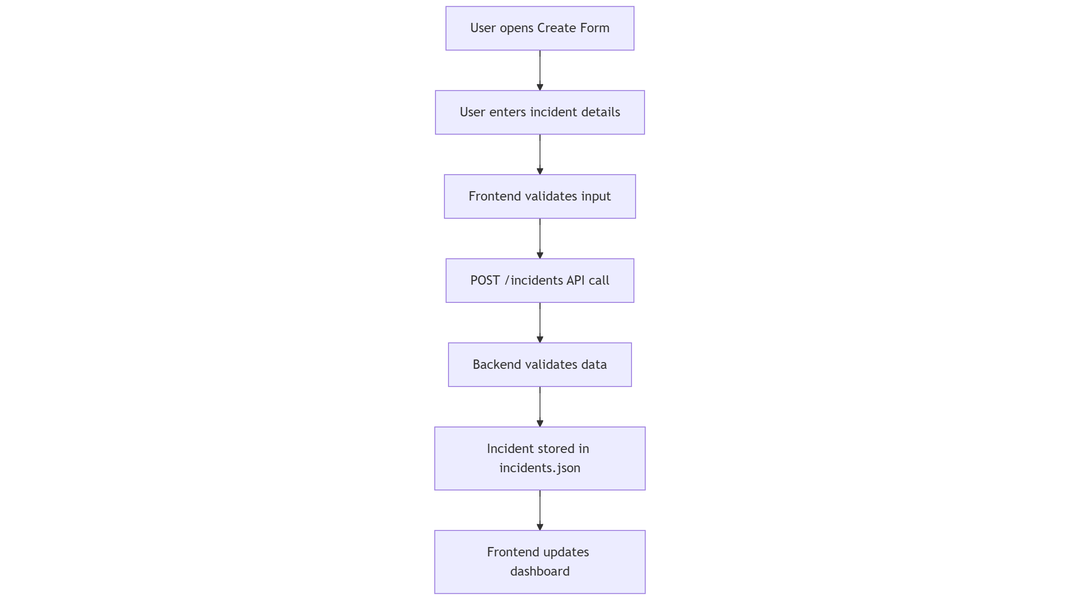

Update incident flowchart
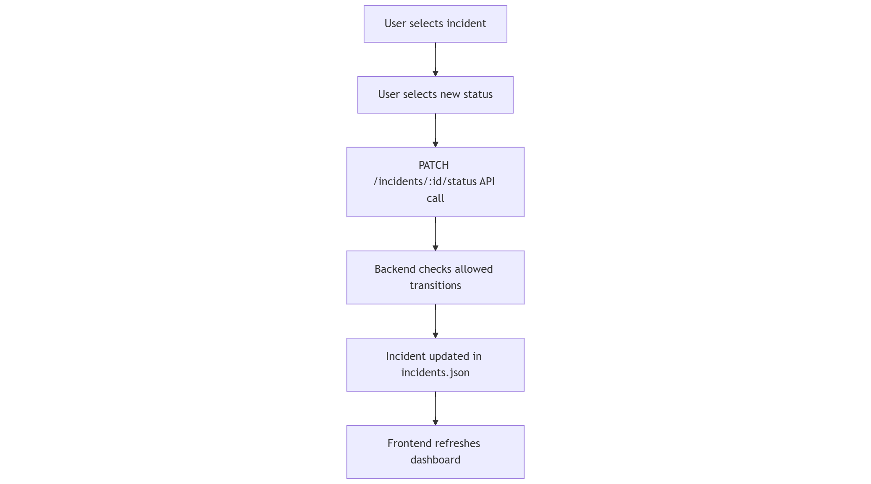

Read incident list-
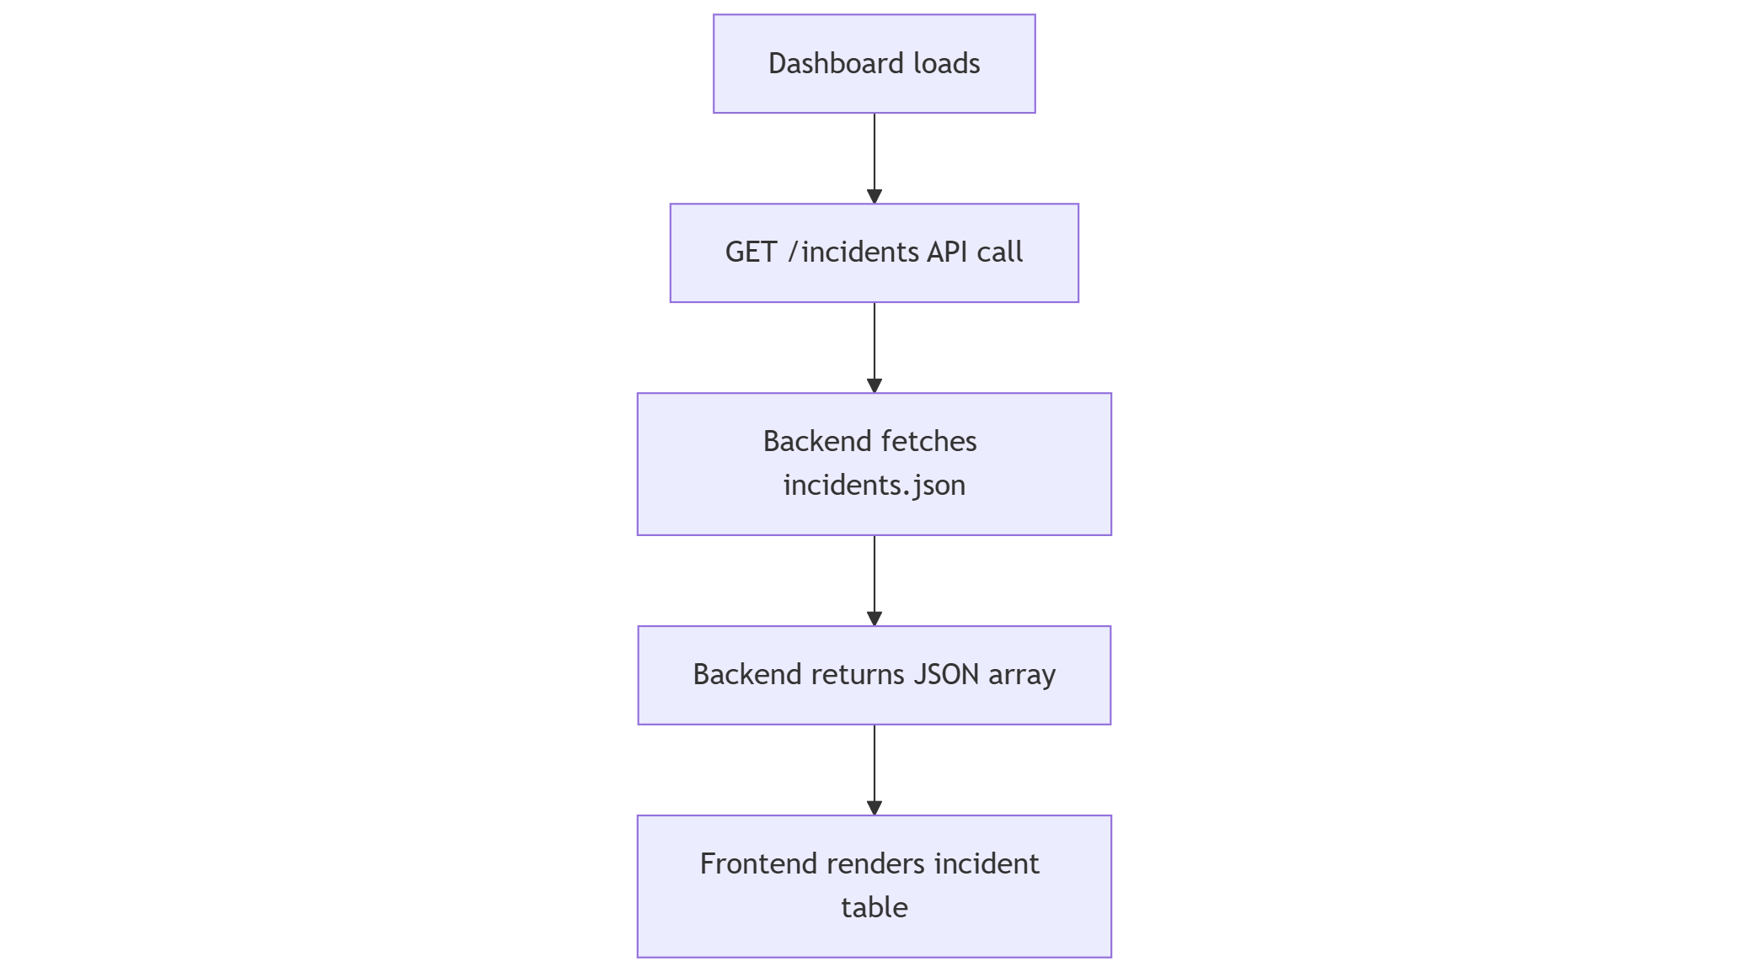
Bulk CSV upload-
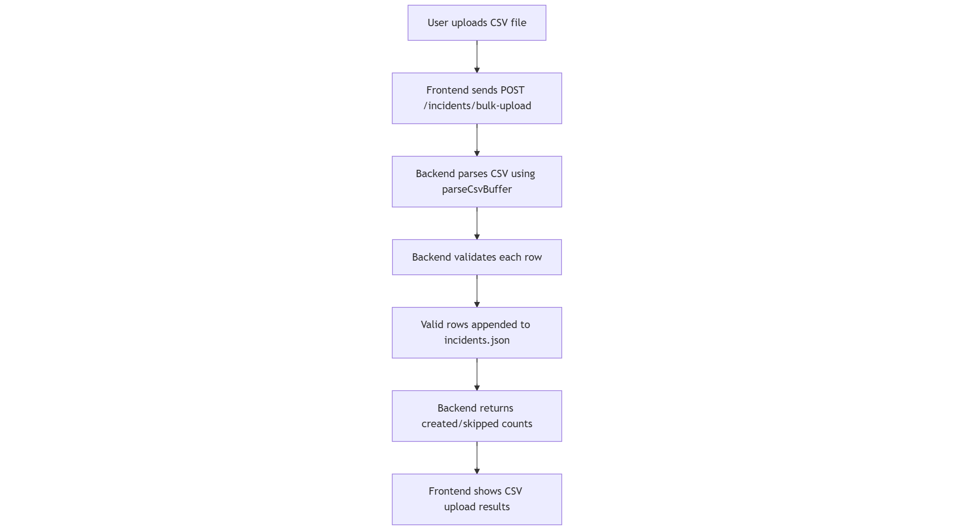

Dashboard Screenshot
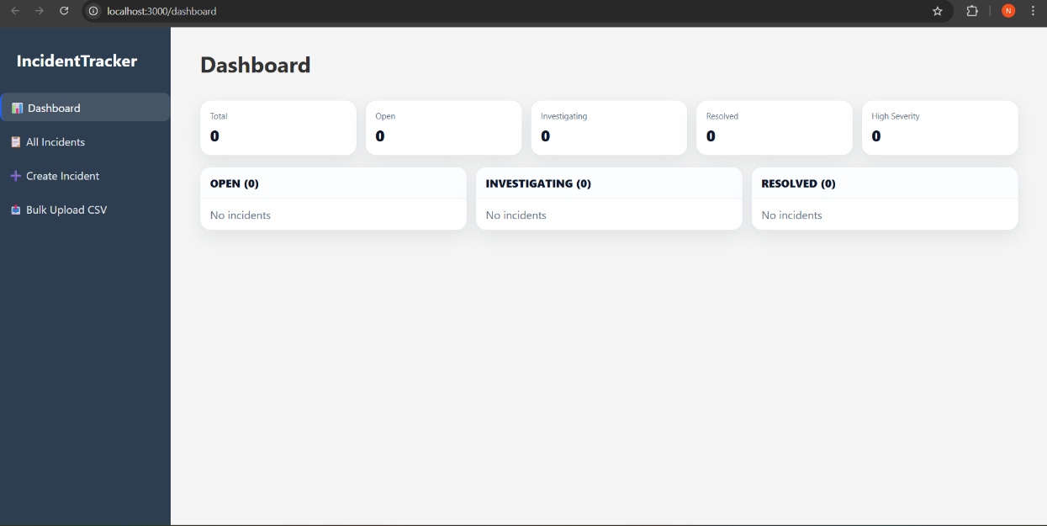

Incident Screenshot
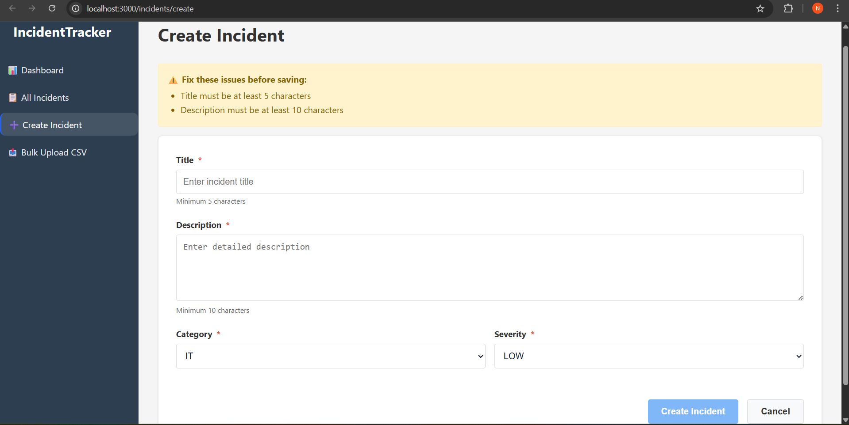

Bulk upload screenshot
